Political Beliefs, Partisanship, and Health Behaviors during the COVID-19 Pandemic: Examining the Role of Political Climates in Behavioral Responses

Christopher Soria
Audrey Dorélien
Dennis Feehan
Ayesha Mahmud

Abstract

Studies during the COVID-19 pandemic systematically showed that political beliefs/affiliations were associated with health behaviors. For instance, they find that Democrats/liberals are more likely to wear masks. We extend this literature by analyzing examining the modulation of partisanship's influence on health behaviors amidst incongruence between individual political affiliations and the prevailing ideologies within their immediate social environments. We take advantage of the Berkeley Interpersonal Contact Study (BICS) which collected information on the number of interpersonal contacts, mask-wearing, and COVID-19 vaccine status during the pandemic. Our initial findings reveal that Republicans, consistent with prior studies, are less concerned about coronavirus spread, a trend unaffected by residing in Democratic-led districts. Behavioral adjustments in face-to-face interactions during the pandemic exhibit subtle variations influenced by the political leaning of the respondent's congressional district, with Democrats and Republicans in Democratic districts showing contrasting tendencies to limit physical interactions.

Introduction

During the COVID-19 pandemic, studies consistently indicated a relationship between political beliefs/affiliations and health behaviors, with Democrats/liberals generally more inclined towards protective measures such as mask-wearing (Lu et al., 2021; Milosh et al., 2020; Howard, 2021; Alcott et al, 2020; Camobreco, He, 2022). Utilizing the rich data from the Berkeley Interpersonal Contact Study (BICS), we embark on a nuanced exploration of this dynamic, probing the interplay between individual political beliefs and the prevailing ideological climate of one's surroundings. Our inquiry is grounded in the hypothesis that the inclination of Democrats/liberals to adopt protective behaviors may be diluted in predominantly Republican/conservative environments, and vice versa, with potential variations by race/ethnicity and region.
Building upon established literature that underscores partisan divisions in health behaviors (Lu et al., 2021; Milosh et al., 2020), our study uniquely delves into the potential modulation of these behaviors by the political alignment of one’s environment. This analysis is particularly vital as it extends beyond the diverse and non-uniform implementation of pandemic-related restrictions across different states, ensuring that we control for these variables to isolate the impacts of political alignment on health behaviors (Gollwitzer, 2020). We aim to trace the progression of the partisanship gap during the first year of the pandemic, offering insights into how individual political beliefs are modulated by the surrounding political environment. This analysis will provide a nuanced understanding of how the layered influences of age, socioeconomic status, and political beliefs collectively shape public responses to health emergencies within varied political contexts.

Data and Methods

We utilized data from the Berkeley Interpersonal Contact Study (BICS), conducted during the initial year of the COVID-19 pandemic, utilizing three of 5 waves from March 2020 to December 2020. BICS offers insights into interpersonal contacts and associated health behaviors, captured via online surveys detailing the frequency and nature of both physical and conversational interactions over specific 24-hour periods. In the full paper, we will focus on data on mask usage, political affiliations, COVID-19 vaccination status, and contacts beyond the household to explore the intersections between these variables. Respondents’ demographic data, education, and ZIP Codes are also included. In this preliminary study, we focus on simple binary outcomes of concern and contact reduction.
log(1−P(Y=1)P(Y=1)​)=β0​+β1​X1​+αTC+γTZ
Where X1 is the predictor, political party to congressional district alignment, C is a vector of county-level controls, including COVID-19 case mortality rate, and Z is vector of respondent's individual characteristics including sex, level of education, and year of birth.
We used the HUD’s Office of Policy Development and Research (PD&R) HUD-USPS ZIP Code Crosswalk data to match ZIP code data from BICS to a congressional district. We then matched the data to House of Representatives members active during 2019-2020, identifying whether each ZIP code was represented by a Republican or Democrat. Lastly, we pulled data from the CDC to control for COVID hospitalizations and Census population counts to calculate mortality rates.

Results

In the preliminary analysis, we observed that Republicans consistently exhibited less concern about the spread of COVID-19 than Democrats, a trend that was unaffected by the political orientation of their congressional districts. When assessing changes in face-to-face interactions, we discovered nuanced variations. Democrats, particularly those in Democrat-led districts, were less likely to reduce interpersonal contacts. Conversely, Republicans in Democratic districts were marginally more inclined to limit such interactions. These patterns were consistent throughout the selected study waves.

These findings introduce an additional layer to the understanding of how political beliefs and affiliations influence health behaviors, particularly during the COVID-19 pandemic. Existing literature predominantly supports the notion that Democrats/liberals are more likely to adhere to recommended health protocols, such as mask-wearing and social distancing. However, this study indicates that the political composition of one’s environment can moderate these behaviors.

Discussion

In its early stages, this research is already shedding light on the complex relationship between individual health behaviors and the surrounding political landscape, particularly exploring the propensity for diminished health-conscious behaviors in politically contrasting environments. Preliminary results indicate a steadfast low level of COVID-19 concern among Republicans, a trend unswayed by residing in Democrat-led districts. Contrastingly, evidence of peer effects emerges, with noticeable alterations in face-to-face interactions for individuals residing in politically discordant districts.

These initial insights hold potential implications for tailoring effective, context-sensitive public health policies, underscoring the need to account for the intricate behavioral nuances shaped by political affiliations. However, the study's constraints, including the broad geographical reach of congressional districts and the omission of influential variables such as population density and urbanicity, necessitate caution. The employment of ZIP Codes, with their inherent overlap issues, further complicates the analysis.

As we advance this research, our focus will be on enhancing methodological precision to navigate these challenges, aiming for a refined exploration that yields deeper, actionable insights into how political and social contexts intersect to shape health behaviors during pandemics. The quest is to extract lessons that can be instrumental in crafting policies adept at navigating the multifaceted human responses to health crises, embedded in and influenced by their political environments.

Plot 1
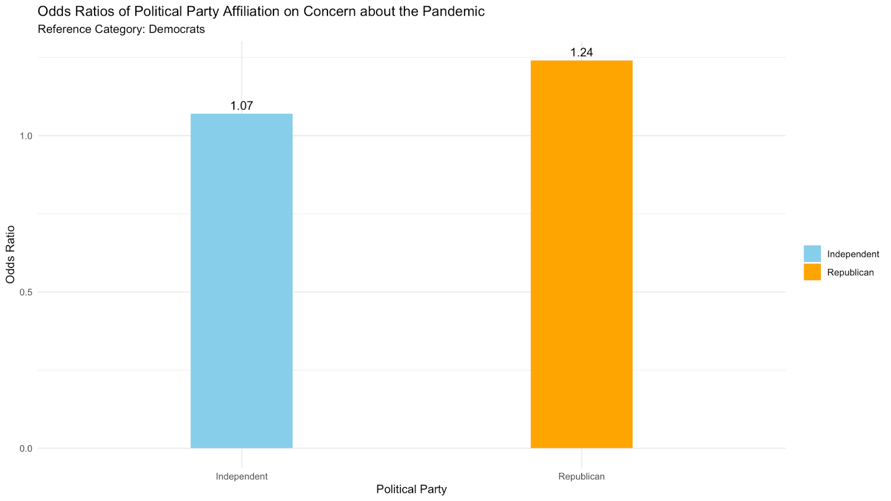

Plot 2

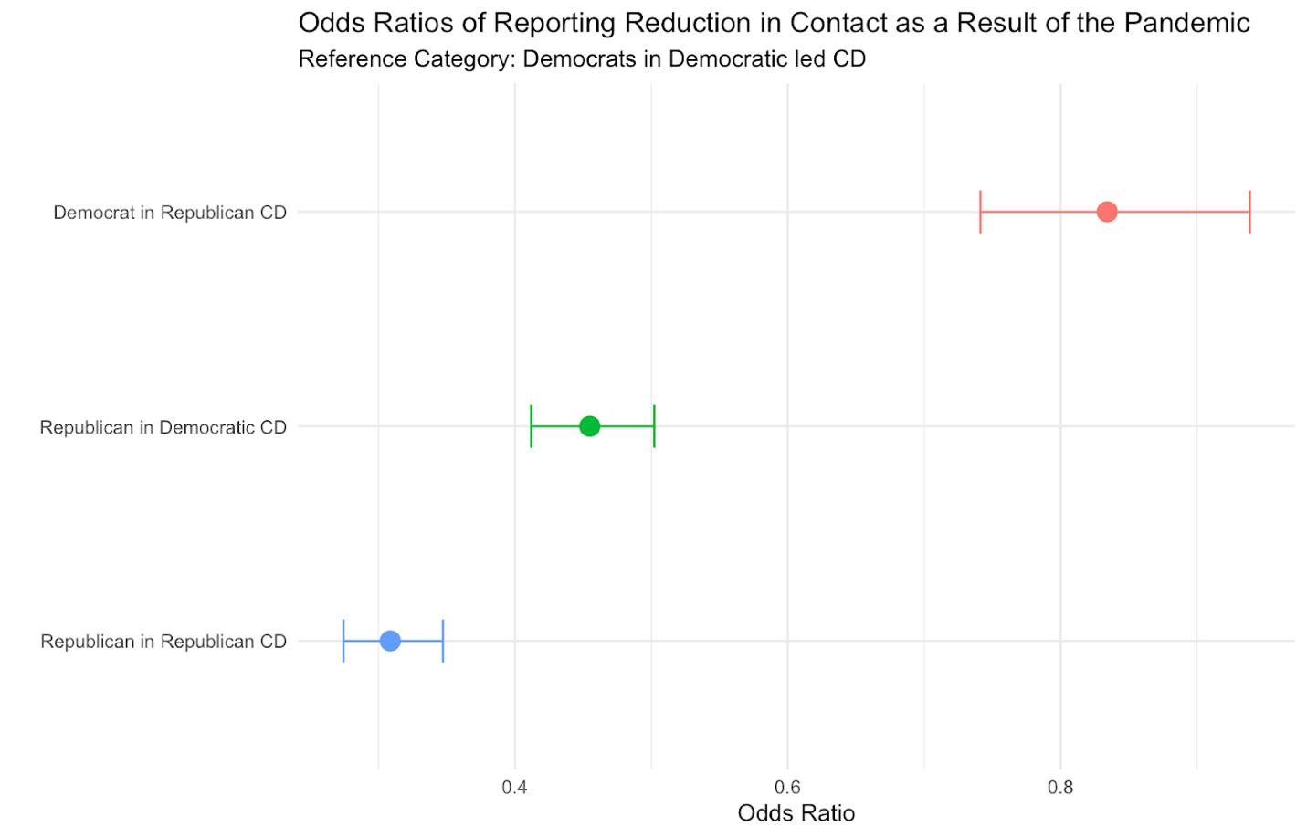

References

Allcott, H., Boxell, L., Conway, J., Gentzkow, M., Thaler, M., & Yang, D. (2020). Polarization and Public Health: Partisan differences in social distancing during the coronavirus pandemic. Journal of Public Economics, 191. https://doi.org/10.3386/w26946

Camobreco, J. F., & He, Z. (2021). The party-line pandemic: A closer look at the partisan response to covid-19. PS: Political Science &amp; Politics, 55(1), 13–21. https://doi.org/10.1017/s1049096521000901

Gollwitzer, A., Martel, C., Brady, W. J., Pärnamets, P., Freedman, I., Knowles, E., & Van Bavel, J. J. (2020). Partisan Differences in Physical Distancing Are Linked to Health Outcomes during the COVID-19 Pandemic. https://doi.org/10.31234/osf.io/t3yxa

Howard, M. C. (2021). Are face masks a partisan issue during the covid‐19 pandemic? differentiating political ideology and political party affiliation. International Journal of Psychology, 57(1), 153–160. https://doi.org/10.1002/ijop.12809

Lu, J. G., Jin, P., & English, A. S. (2021). Collectivism predicts mask use during COVID-19. Proceedings of the National Academy of Sciences, 118(23). https://doi.org/10.1073/pnas.2021793118

Milosh, M., Painter, M., Van Dijcke, D., & Wright, A. L. (2020). Unmasking partisanship: How polarization influences public responses to collective risk. SSRN Electronic Journal. https://doi.org/10.2139/ssrn.3664779

